ADOGRC Connect for Power BI
Version 1.0

Content
1. Scenario Overview 3
2. Architecture 4
3. Setup 4
3.1 . Prerequisites 4
3.2 . Unlock Basic Auth in Admin Toolkit 4
3.3 . Allow authentication in the web application 6
4. Test the ADOGRC Connect for Power BI 6
5. Security 7
6. Changes with ADONIS 14.0 7

- Scenario Overview
The ADOGRC Connect for Power BI enables a connection between the data stored in ADOGRC and Power BI.
Note: This document focuses on the integration with ADOGRC. Integration with ADONIS and ADOIT is also possible with only minor metamodel adjustments.
The current version of the module supports the following features:
- Dashboard: There is a predefined dashboard for Internal Control System Portfolio in ADOGRC that shows the most important data regarding your risk management in ADOGRC. By changing the data source in Power BI, the dashboard will automatically be updated with your ADOGRC data. The dashboard can also be easily adapted, in case you want to focus on different aspects of your applications.
- Reports: It is possible to embed your Power BI dashboard in MS Teams or PowerPoint to keep your colleagues in the loop.
- Real-time Synchronization: View your ADOGRC data in real-time in Power BI by synchronizing your dashboard.
The following image shows an example of a dashboard in Power BI which contains data retrieved from ADOGRC:
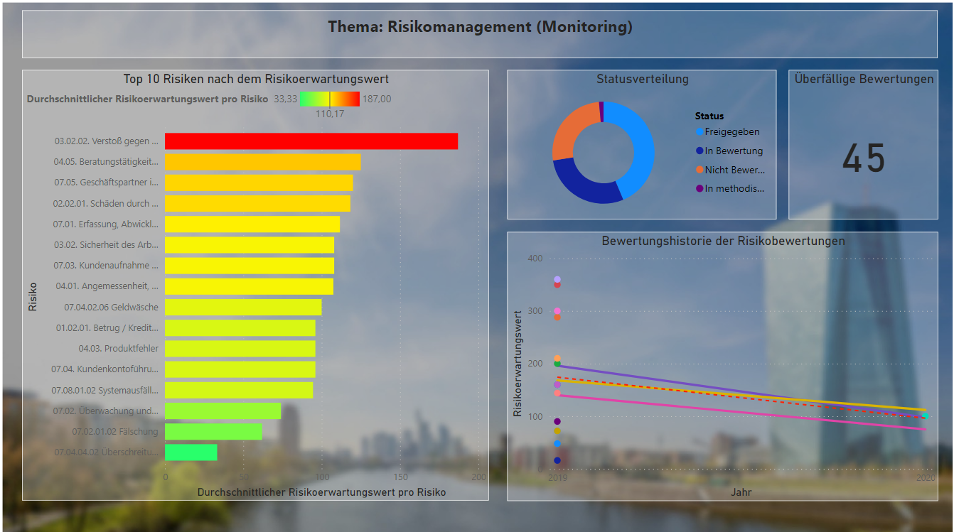
Figure 1: Example dashboard in Power BI showing data of risk management in ADOGRC

- Architecture
Communication between ADOGRC and Power BI is realized via a REST-URL. Power BI needs the BASE URL of the ADOGRC version that the user is currently using.
- Setup
  - . Prerequisites
ADOGRC 11.1.0 or higher and Power BI Desktop 2.9 or higher must be installed.
  - . Unlock Basic Auth in Admin Toolkit
- Library Management
To access the ADOGRC data in Power BI, Basic Auth must first be allowed in the Admin Toolkit. To do this, open the Admin Toolkit and click on the "Library Management" section. Then click on "Component Settings" and expand the ADOGRC metamodel by clicking on the plus. Next, open “Standard RESTtful services” and select "General".
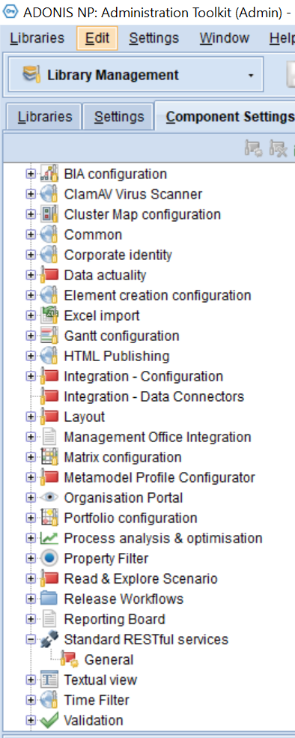
Figure 2: Component Settings – Admin Toolkit
- Settings Standard RESTful Services
The next step is to enable MFB REST globally in the “Token” tab and activate a technical user from the default group.
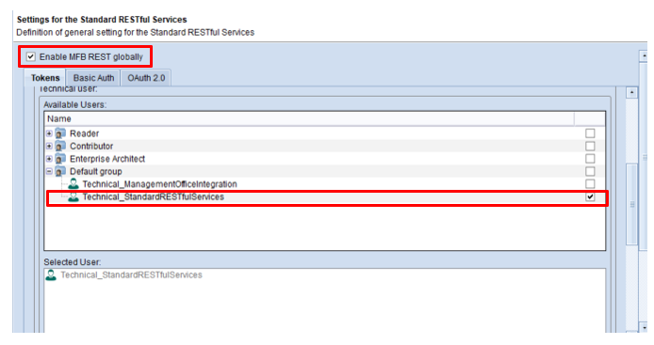
Figure 3: Enable Standard RESTful Services
- Basic Auth
Then go to the "Basic Auth" tab and enable all repository scenarios. When all steps are done, click "OK" and restart the application server.
Figure 4: Enable Repository Scenarios
  - . Allow authentication in the web application
Under the path webapps/<ADO>/WEB-INF/rest/RESTAuthorization.xml authentication must be allowed in the web application. To do this, one must remove the comments around <entry key="REST_BASIC_AUTHENTICATION">true</entry>. Open the file in a program where you can edit (e.g. Notepad). Then delete the comments as mentioned above.

The code should look this in the end:
<?xml version="1.0" encoding="UTF-8"?>
<!DOCTYPE properties SYSTEM "http://java.sun.com/dtd/properties.dtd">
<properties>
<comment>Trusted RESTful callers with their secret key</comment>
<!-- True of the rest authentication secret is encrypted, otherwise false -->
<entry key="ENCRYPTED">true</entry>
<!-- The key and its secret.
If the ENCRYPTED flag is set to true then the secret must be encoded via ADOxx API ado.util.encrypt (recommended). -->
<!--<entry key="%KEY%">%SECRET%</entry>-->
<entry key="REST_BASIC_AUTHENTICATION">true</entry>
</properties><entry key="REST_BASIC_AUTHENTICATION">true</entry>
</properties>

- Test the ADOGRC Connect for Power BI
Perform the following steps to test the ADOGRC Connect for Power BI
Start the services for ADOGRC and open ADOGRC in the browser. Then copy the Base URL of your ADOGRC version, e.g.: https://integrated-grc-demo.boc-cloud.com/.
Then open the predefined template. A window should pop up asking you to enter your Base URL.
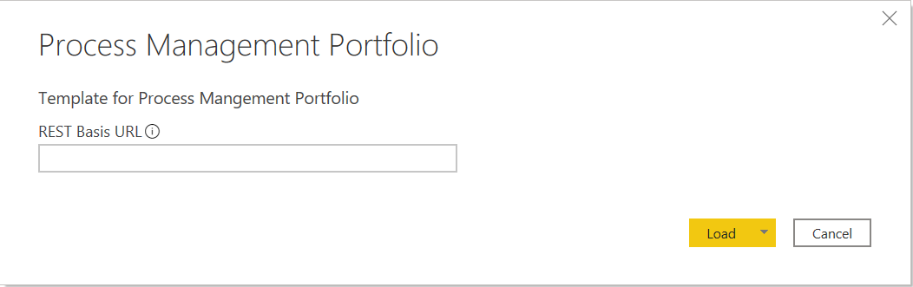
Template for Risk Management Portfolio
Risk Management Portfolio
Figure 4: Rest Base URL
Then enter the rest base URL you copied earlier and add /rest/2.0/ at the end. Your input should then look something like this: https://integrated-grc-demo.boc-cloud.com/rest/2.0/. Make sure that the ADOGRC services are running, as Power BI pulls the ADOGRC data directly from the web.
Once all these steps have been completed, the template should be filled with your data and your data will be visualised in Power BI.
- Security
The fact that Basic Authentication has to be permitted for Power BI means that it is also generally enabled.
However, this should not cause any security problems, as the user's credentials as well as the repository and query ID are also required to gain access to the data.

- Changes with ADONIS 14.0

Now with ADONIS 14.0 it is even easier to transfer data from ADOGRC to Power BI.
You do not have to globally enable or disable basic authentication in a configuration file anymore. Instead, you can define IP addresses and system roles on the Admin Page for access control.
More detailed instructions on how to enable basic authentication can be found in our online help: https://docs.boc-group.com/adonis/en/docs/14.0/administration_manual/lbm-000000/#libcs-L7000
You have to allow basic authentication for all IP addresses. The code in the security settings should look like this after editing:
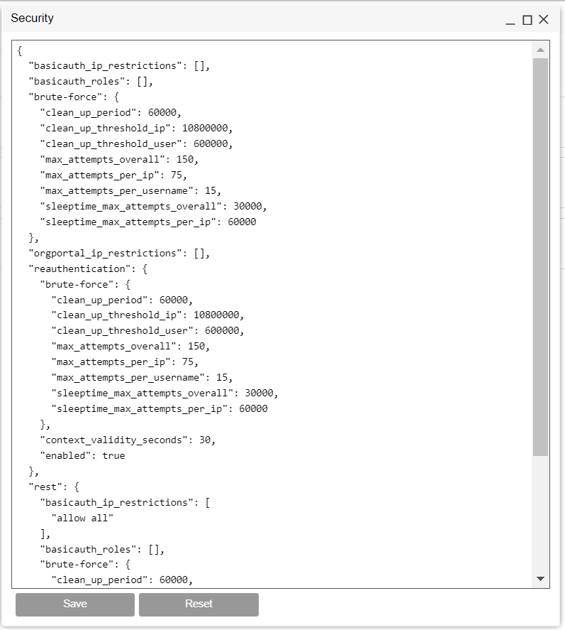
Figure 5: Allow basic authentication as administrator

